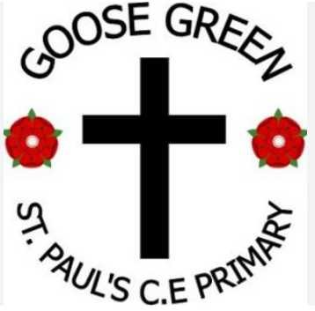
St Pauls C. E. Primary School

“Learning and living through Jesus Christ”
January 2026 – Our Value for life: Courage
The value of Courage: "Be of good courage " Psalm 31:24
Head Teacher’s Hello  30.1.26
Dear all, May I take this opportunity to thank all the children and lovely parents that have made me feel so welcome in joining the ST Paul’s school community. The staff have been amazing and work so hard to deliver learning and love to your children each day, it is wonderful to see.
We have re-introduced School Councillors with elections this week and have ordered badges … they are on there way and I hope to be presenting the children shortly. I am also truly spoilt for choice when I choose those for the Head Teacher Awards each week, however this is a lovely problem to have and the children who receive them have said how much they mean to them, which is so lovely to hear.
We plan to have a newsletter every two weeks to share what is happening in school with you and hope you will enjoy hearing all about school life.
Mrs Mowbray
“Share all good things with the one who teaches” Galatians 6:6



Science Y3
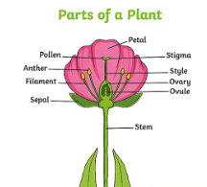

What can we share this week?


Phonics : Reception
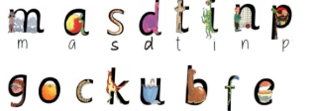

PE: Dance Y5


Math: Y6
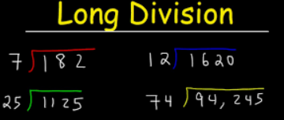

Week in pictures…

We are a church school 
In collective worship We have
been thinking about …Daniel and having the courage to trust.

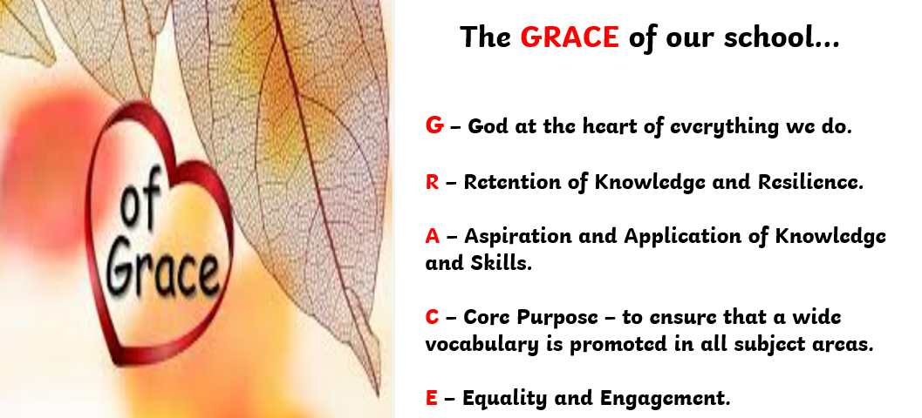
St Paul’s Governors:
Chair of Governors – Mrs J Lavin
Head Teacher – Mrs K Mowbray
Staff Governor – Mr A Rigby
Parent Governor –
Parent Governor –
Foundation Governors –
If you wish to contact them, you can do so via the school email:




Learn, Love and Achieve with Jesus …

Part of 18 schools … 6 more next week !

Our Trust’s Prayer 
Heavenly Father,
Let peace, friendship and love grow in our schools.
Send the Holy Spirit to give excellence to our learning,
love to our actions and joy to our worship.
Guide us to help others, so that we may all
Learn, Love and Achieve,
Together with Jesus.
Amen



Is my child too ill for school?
It can be tricky deciding whether to keep your child off school or nursery when they are unwell.
There are government guidelines for schools and nurseries, these say when children should be kept off school and when they shouldn't. https://www.nhs.uk/live-well/is-my-child-too-ill-for-school If you do keep your child at home, it's important to phone school or nursery daily.

Please remember we are a nut free school, we have children in school with nut allergies, therefore please ensure your child’s snack and packed lunch do not contain any nuts and check ingredients if you are not sure. Please DO NOT SEND ANY CHOCOLATE SPREAD products on sandwiches as some do contain nuts.

YOU are special, gifted and talented…

Do you have a picture to share of something you want to share with others …it may be from a football match , gymnastic club, church group, guides, scouts or anything else that we can celebrate as uniquely you?

Please send to the school office by email :

We would love to celebrate YOU.



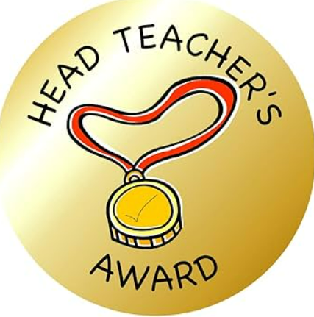
Head Teacher Awards
Week: 23.1.26 Week:30.1.26

Reception: Poppy Reception: Dalton

Year 1:Paisley Year 1:Illiyah

Year 2: Aaron Year 2:Eloise

Year 3: Willow Year 3:Sienna

Year 4: Luca Year 4:Lucas

Year 5: Jacob Year 5:Zainab

Year 6: Scarlett Year 6:Marley

ATTENDANCE
LDST and ST Pauls school attendance target : 97%
Whole school attendance to date is:
Week:23.1.26 Week 30.1.26
Reception class | 85.3%
Year 1 class | 93.7%
Year 2 class | 97.4%
Year 3 class | 98%
Year 4 class | 92.3%
Year 5 class | 94.5%
Year 6 class | 95.5%



