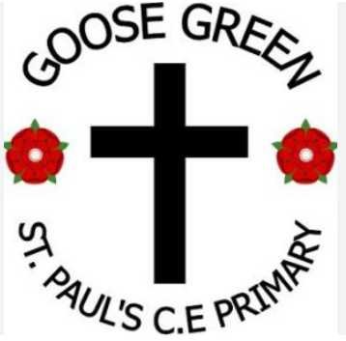
St Pauls C. E. Primary School

“Learning and living through Jesus Christ”
January 2026 – Our Value for life: Courage
The value of Courage: "Be of good courage " Psalm 31:24
Head Teacher’s Hello  27.2.26
Dear all, As we begin the Spring 2 term, I would like to take a moment to reflect on just how much our children achieved during the last half term. Their hard work, creativity, and enthusiasm have been evident in every classroom, and it has been a joy to see them grow in confidence and character. Whether tackling new challenges, supporting one another, or sharing their learning with pride, the children continue to show what a special, caring community we are building together.
Looking ahead, Spring 2 promises to be a vibrant and exciting period in our school calendar. With fresh topics to explore, and the anticipation of new experiences, there is much for the children to look forward to. One of the highlights will undoubtedly be our upcoming World Book Day celebrations, a wonderful chance to immerse ourselves in stories, imagination, and the joy of reading. Thank you, as always, for your continued support. Mrs Mowbray.
“Let all that you do be done in love.” – 1 Corinthians 16:14

If you'd like it even longer, more formal, or more reflective, feel free to tell me your preferred style!

. “Let all that you do be done in love.” – 1 Corinthians 16:14

Mrs Mowbray

“Share all good things with the one who teaches” Galatians 6:6





Maths YR


What can we share this week?
Music Year 3


Maths Year 6
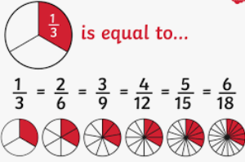

PE: Y4
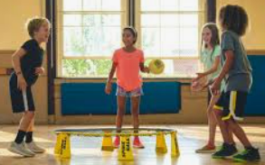

Week in pictures…

We are a church school 

We are exploring the Christian value of forgiveness.


St Paul’s Governors:
Chair of Governors – Mrs J Lavin
Head Teacher – Mrs K Mowbray
Staff Governor – Mr A Rigby
Parent Governor – Caroline Faleti
Parent Governor – Jimena Hill
Foundation Governors – Lucy Haigh
- Jan Lavin
- Ann Birch
If you wish to contact them, you can do so via the school email: communication.stpauls@ldst.org.uk




Learn, Love and Achieve with Jesus …

Part of 18 schools … 6 more next week !

Our Trust’s Prayer 
Heavenly Father,
Let peace, friendship and love grow in our schools.
Send the Holy Spirit to give excellence to our learning,
love to our actions and joy to our worship.
Guide us to help others, so that we may all
Learn, Love and Achieve,
Together with Jesus.
Amen

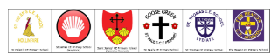

Is my child too ill for school?
It can be tricky deciding whether to keep your child off school or nursery when they are unwell.
There are government guidelines for schools and nurseries, these say when children should be kept off school and when they shouldn't. https://www.nhs.uk/live-well/is-my-child-too-ill-for-school If you do keep your child at home, it's important to phone school or nursery daily.

Please remember we are a nut free school, we have children in school with nut allergies, therefore please ensure your child’s snack and packed lunch do not contain any nuts and check ingredients if you are not sure. Please DO NOT SEND ANY CHOCOLATE SPREAD products on sandwiches as some do contain nuts.

YOU are special, gifted and talented…

Do you have a picture to share of something you want to share with others …it may be from a football match , gymnastic club, church group, guides, scouts or anything else that we can celebrate as uniquely you?

Please send to the school office by email : communication.stpauls@ldst.org.uk

We would love to celebrate YOU.




Head Teacher Awards
Week: 27.2.26 week:6.3.26.

Reception: Aurora Reception:

Year 1: Theo Year 1:

Year 2:Charlie Year 2:

Year 3: Theo Year 3:

Year 4: Scarlett Year 4:

Year 5: Layton Year 5:

Year 6: Alannah Year 6:

Noah has some art being put on show in the wigan arts
exhibition next month.
He has been helped by a family friend.


ATTENDANCE
LDST and ST Pauls school attendance target : 97%
Whole school attendance to date is:
Week:6.2.26 Week 13.2.26
Reception class | 97.4% | 97.9%
Year 1 class | 94.8% | 95.9%
Year 2 class | 98.9% | 94.4%
Year 3 class | 96.7% | 97.3%
Year 4 class | 98.4% | 96.8%
Year 5 class | 95.8% | 96.3%
Year 6 class | 89% | 93.5%

Please be Reminded of our School Uniform
The registered suppliers of our named uniform are Slater’s (Wigan) & A.C. sports (Pemberton). All cardigans and jumpers must be purchased from one of these registered suppliers.

We encourage parents and carers to purchase all other forms of uniform from the most competitively priced supplier. This could be a supermarket chain or a market stall. Equally, as part of our commitment to sustainability we would encourage parents to visit Wellspring where many, many items of pre-loved good condition uniform is always available.

GIRLS
Cardigan St Paul’s design with school badge (required)
Skirt/ Pinafore dress Mid Grey
Trousers (Winter only) Mid Grey
Polo Shirt White polo shirt
Blouse Plain white
Tie Red
Summer dress Red gingham
Shoes Flat, black, grey, red or white
Tights Black, grey, red or white
Hair accessories / bobbles Black, grey, red or white

BOYS
Jumper St Paul’s design with school badge (required)
Trousers Mid Grey
Polo shirt White polo shirt
Shirt Plain white
Tie Red
Shoes Black, grey, red or white
Socks Mid grey, white or black
P.E.
For reasons of safety, health and hygiene, all children need to change for Physical Education.
Each child should have:
‘T’ Shirt (in house colour - required), shorts (black - required), pumps (black - required), PE bag (in house colour - required).
Swimming Kit (Year 3) – required. Please name all items of uniform



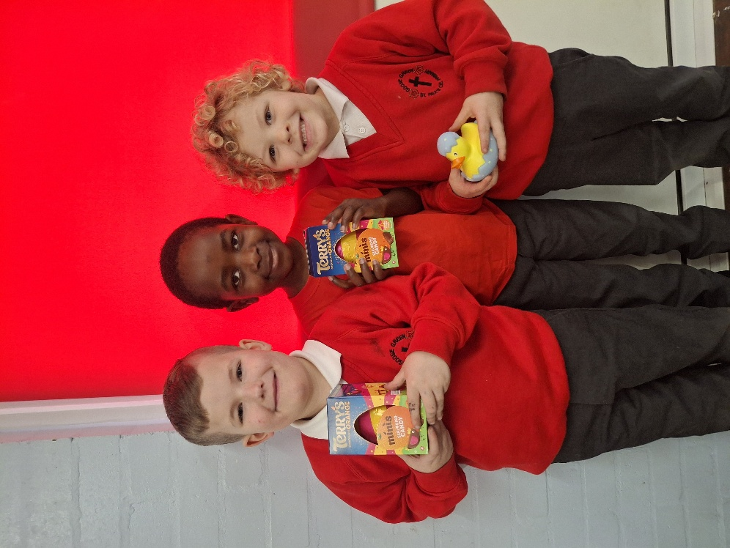
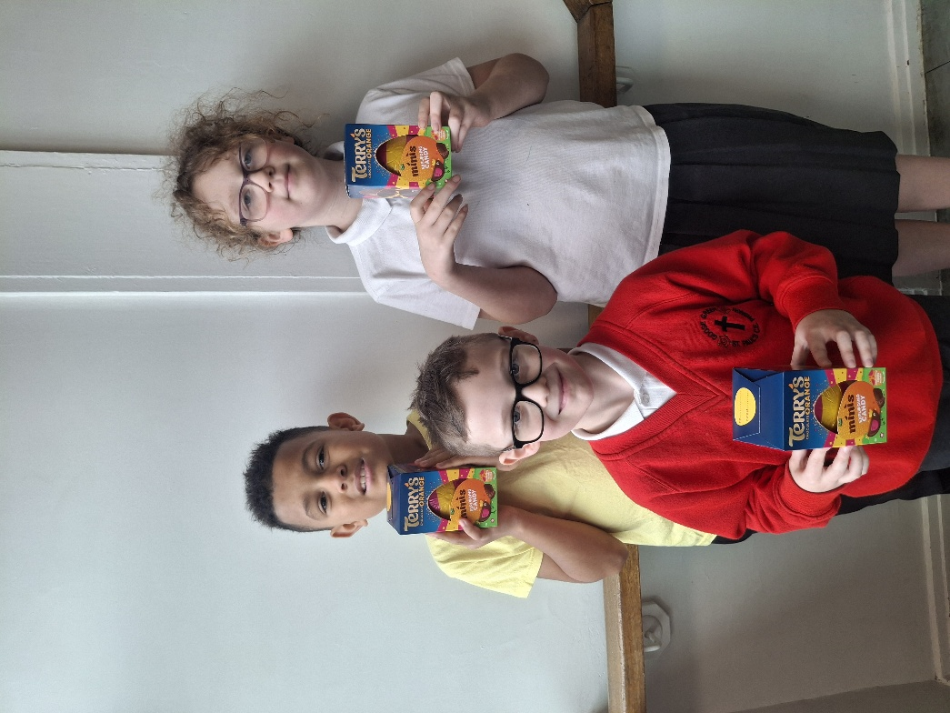


Congratulations to the winners of our very first Early Bird Raffle, enjoy your prize.
We will let you know what day next week our Early bird attendance raffle will take place.

