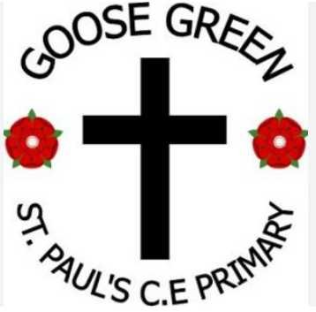
St Pauls C. E. Primary School

“Learning and living through Jesus Christ”
January 2026 – Our Value for life: Courage
The value of Courage: "Be of good courage " Psalm 31:24
Head Teacher’s Hello  13.2.26
Dear all,
We have had a packed half term full of learning for our children. Children, particularly in year 4, are practicing their fluency with times tables and we have also introduced an ECO team, more news to come about their aims soon.
School Council badges have arrived and will be given in collective worship We are also creating a display board in school for all those that lead: Ethos team (God Squad), school council and Eco Team; this is so we can celebrate their contribution to the school.

Wishing everyone a safe and enjoyable half term holiday and see you back in on Monday 23rd February. Mrs Mowbray
“Be strong and take heart all you who hope in the Lord” Psalm 31:24

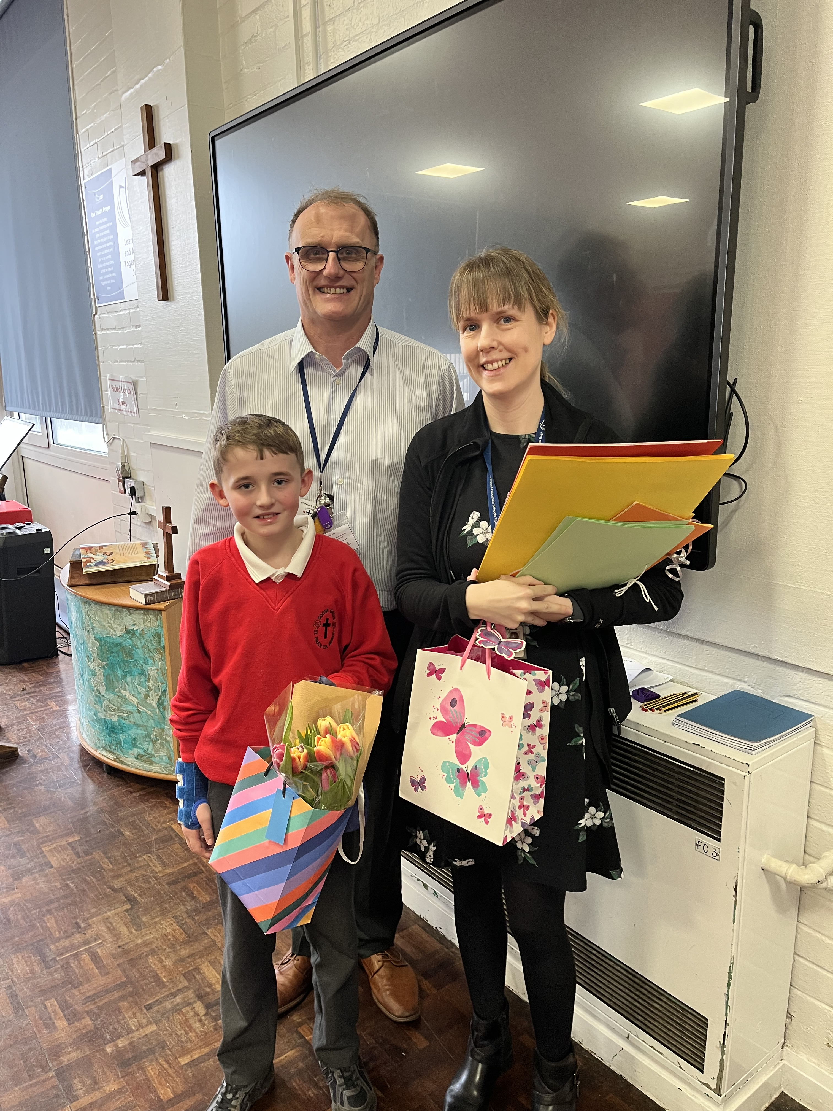
We are sad to say goodbye to Miss Norris who has been with the school for over ten years. She has taught across all year groups and has worked in class and small groups to support our children. She will be greatly missed but we all wish her well as she starts her new adventure. She will always be a part of our St Paul’s family and we hope she comes back to visit.

Week in pictures…
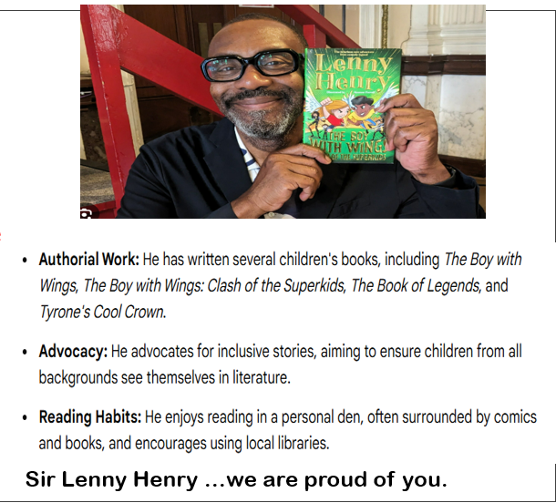

Handwriting Y2
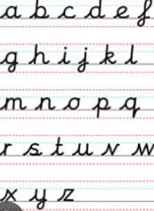

What can we share this week?
Geography Year 1
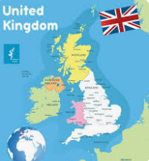

English Year 5


Math: Y4
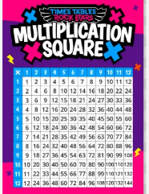

We are a church school 
We have been exploring people
who inspire us …Sir Lenny Henry.
We have also been thinking of how love
never fails and how the Lord gives courage
who

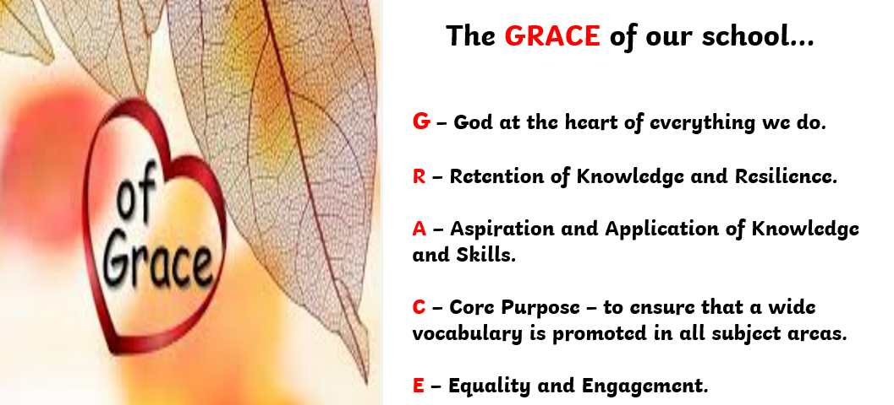
St Paul’s Governors:
Chair of Governors – Mrs J Lavin
Head Teacher – Mrs K Mowbray
Staff Governor – Mr A Rigby
Parent Governor – Caroline Faleti
Parent Governor – Jimena Hill
Foundation Governors – Lucy Haigh
- Jan Lavin
- Ann Birch
If you wish to contact them, you can do so via the school email: communication.stpauls@ldst.org.uk



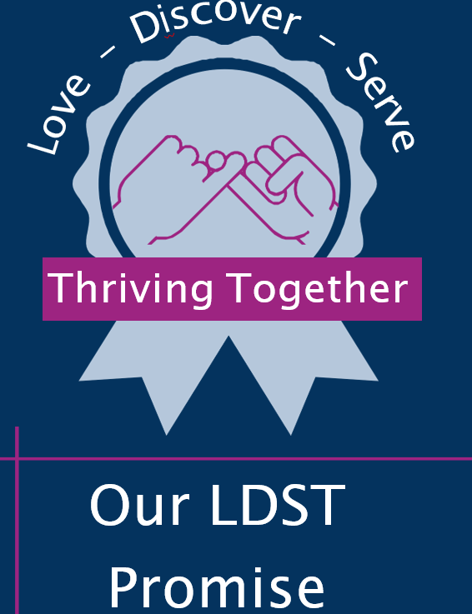
Learn, Love and Achieve with Jesus …

Part of 18 schools … 6 more next week !

Our Trust’s Prayer 
Heavenly Father,
Let peace, friendship and love grow in our schools.
Send the Holy Spirit to give excellence to our learning,
love to our actions and joy to our worship.
Guide us to help others, so that we may all
Learn, Love and Achieve,
Together with Jesus.
Amen



Is my child too ill for school?
It can be tricky deciding whether to keep your child off school or nursery when they are unwell.
There are government guidelines for schools and nurseries; these say when children should be kept off school and when they shouldn't. https://www.nhs.uk/live-well/is-my-child-too-ill-for-school If you do keep your child at home, it's important to phone school daily.

Please remember we are a nut free school; we have children in school with nut allergies. Therefore, please ensure your child’s snack and packed lunch do not contain any nuts and check ingredients if you are not sure. Please DO NOT SEND ANY CHOCOLATE SPREAD products on sandwiches as some do contain nuts.

YOU are special, gifted and talented…

Do you have a picture to share of something you want to share with others …it may be from a football match , gymnastic club, church group, guides, scouts or anything else that we can celebrate as uniquely you?

Please send to the school office by email :

We would love to celebrate YOU.



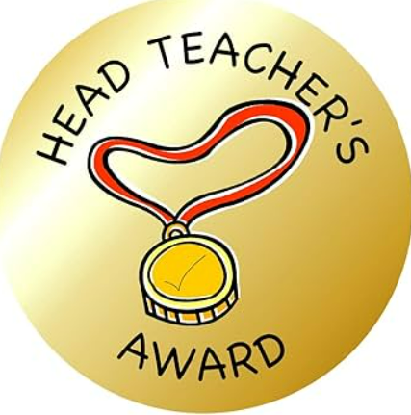
Head Teacher Awards
Week: 6.2.26 Week:13.2.26

Reception: Bonnie Reception: Betty

Year 1: Diana Year 1: Ivy

Year 2: Lucy Year 2: Kaiden

Year 3: Theo Year 3: Honey

Year 4: Scarlett Year 4: Benjamin

Year 5: Layton Year 5: Jimmy

Year 6: Alannah Year 6: Millie-Rose

School Council
Year 2 | Year 3 | Year 4 | Year 5 | Year 6
Hardwin  Emily | Grace  Jonah | Sam  Scarlett | Charlotte  Callum | Ethan  Carter
Introducing our school council here to make a difference…

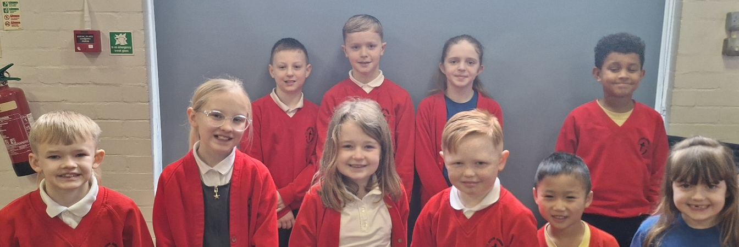

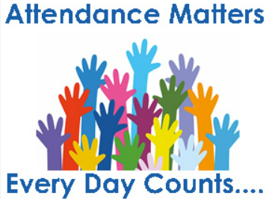
ATTENDANCE
LDST and ST Pauls school attendance target : 97%
Whole school attendance to date is: 96.2%
WC :2.2.26 WC: 9.2.26
Reception class | 97.4% | 96.5%
Year 1 class | 94.8% | 95.1%
Year 2 class | 98.9% | 98.1%
Year 3 class | 96.7% | 97.8%
Year 4 class | 98.4% | 96.8%
Year 5 class | 95.8% | 96.5%
Year 6 class | 89% | 91.4%

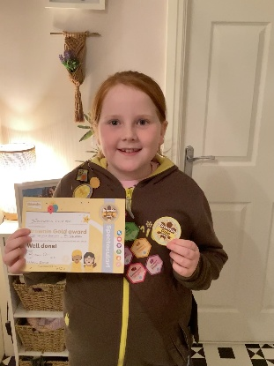

Izabella has earned her Brownie Gold Award which is the highest award that can be earned in Brownies.
She is the 5th person to achieve the award in her unit - and the youngest as she actually completed it when she was 8.
We are extremely proud of her achievements. Her next challenge is to earn all 36 interest badges - of which she has already completed 16.

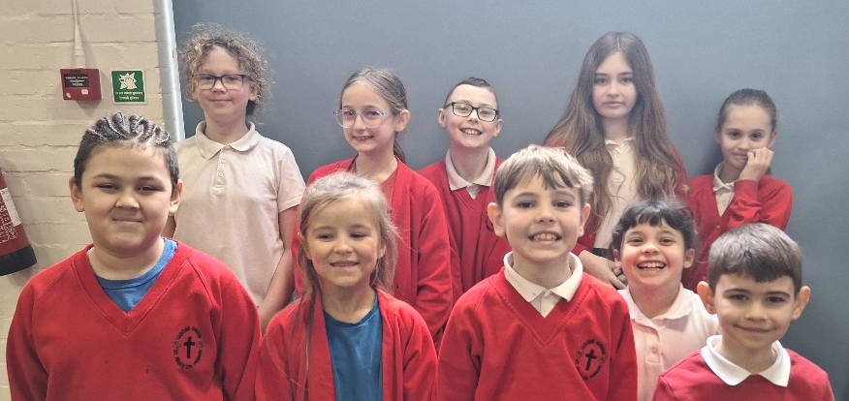
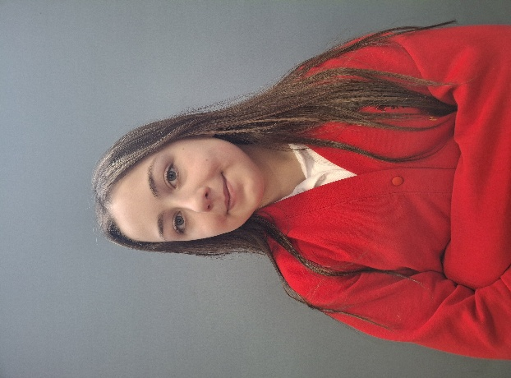
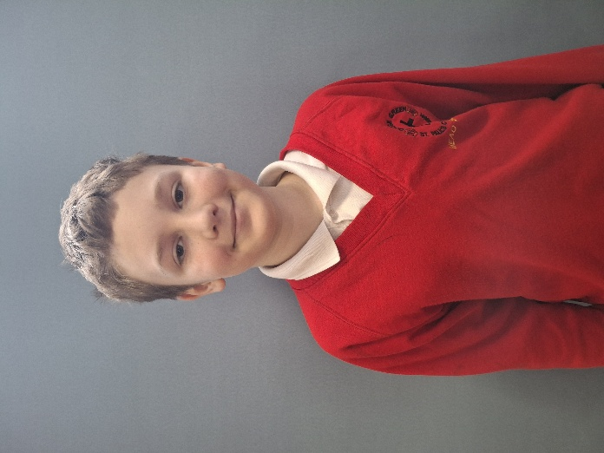
Head Girl & Head Boy
Introducing our school Head Boy and Head Girl

Poppy Dominic
Ethos Team
Year 2 | Year 3 | Year 4 | Year 5 | Year 6
Eloise  Gabriel | Zerrin  Zachary | Harlow  Lucas | Ava  Luke | Willow  Freya
Introducing our school Ethos Team

