
St Pauls C. E. Primary School

“Learning and living through Jesus Christ”
– Our Value for life: Respect
“Show Respect to everyone “ 1 Peter 2:17

Head Teacher’s Hello  09.10.26
Dear all,
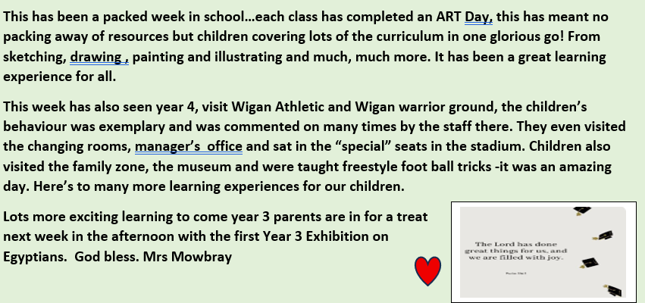

Y5 Art day
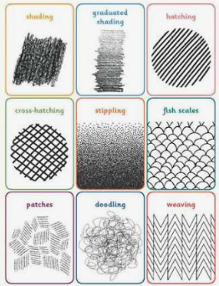

Year 4 Visit -Crusty


Year 3 -Egyptians


Reception PE
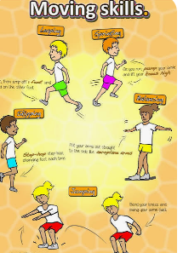

Week in pictures
What can we share this week?


Wanted….Do you have any Lego or Duplo bricks that need a good home…We would love to have them to add to our playtime equipment …Can you help?

Please remember we are a nut free school, we have children in school with nut allergies, therefore please ensure your child’s snack and packed lunch do not contain any nuts and check ingredients if you are not sure. Please DO NOT SEND ANY CHOCOLATE SPREAD products on sandwiches as some do contain nuts.

From September 2026, the Department for Education has made some changes to the way that Free School Meals are allocated. All families and children will need to be rechecked to ascertain whether they can still receive this entitlement.
Please select the link below. This will take you to an online form where you can enter your details which will enable a check to take place. You will need to enter your Name, Date of Birth and National Insurance details. Apply for free school meals | Instructions – Wigan Council
The earlier that this is completed, the sooner we can advise
you of your child's entitlement for 2026/2027 academic year.

St Paul’s Governors:
Chair of Governors – Mrs J Lavin
Head Teacher – Mrs K Mowbray
Staff Governor – Mr A Rigby
Parent Governor – Caroline Faleti
Parent Governor – Jimena Hill
Foundation Governors - Lucy Haigh
- Jan Lavin
- Ann Birch
If you wish to contact them, you can do so via the school email: communication.stpauls@ldst.org.uk





Learn, Love and Achieve with Jesus …
Schools coming together in prayer…

Is my child too ill for school?
It can be tricky deciding whether to keep your child off school or nursery when they are unwell.
There are government guidelines for schools and nurseries, these say when children should be kept off school and when they shouldn't. https://www.nhs.uk/live-well/is-my-child-too-ill-for-school If you do keep your child at home, it's important to phone school or nursery daily.



ATTENDANCE
LDST and ST Pauls school attendance target: 97%
Whole school attendance to date is: 96.7%
Week: 02.10.2026 Week 09.10.26
Year 1 class | 93.2% | 93.9%
Year 2 class | 98.3% | 97.3%
Year 3 class | 99.5% | 99.2%
Year 4 class | 96.4% | 96.8%
Year 5 class | 95.8% | 96%
Year 6 class | 97.1% | 97.5%

Year 3 Exhibition
Year 3 are holding a history exhibition on Thursday 15th October, for the children in school and Year3’s parents/grandparents and carers.

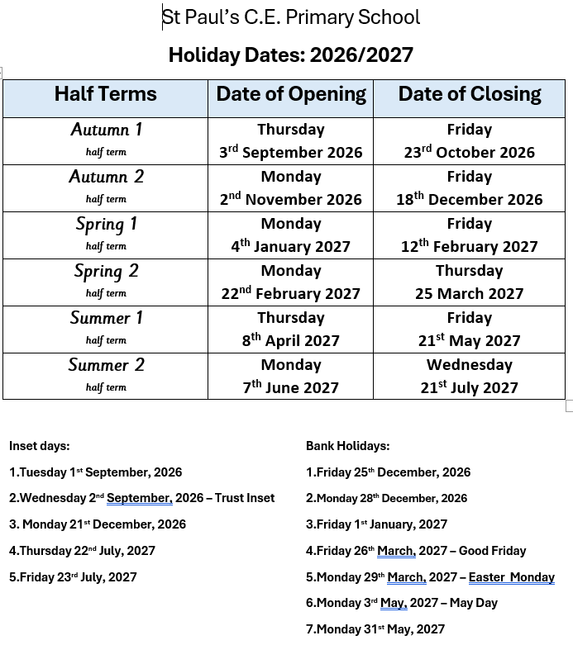



YOU are special, gifted and talented…

Do you have a picture to share of something you want to share with others …it may be from a football match, gymnastic club, church group, guides, scouts or anything else that we can celebrate as uniquely you?

Please send to the school office by email : communication.stpauls@ldst.org.uk



Head Teacher Awards

02/10/2026 9/10/2026
Reception  Harley S | Reception  Maddison
Year 1  Darci | Year 1  Isaac
Year 2  Leo | Year 2  Mouhammed
Year 3  Freya | Year 3  Betsy
Year 4  Ayat | Year 4  Layla
Year 5  Juneau | Year 5  George
Year 6  Luke | Year 6  Jacob


Parent Evening
Wednesday 21 October 2026
2.30pm- 6.00pm
Mrs Mowbray is delighted to invite you to the Autumn Term Parents Evening which we will be holding from 2.30pm – 6.00pm
This is an opportunity for you to meet your child’s teacher and discuss how they are settling into their year group to date. We will discuss with you, your child’s targets and suggest strategies to support your child at home.
Advance Notice
Harvest Service
At st Paul’s church on the 22nd October 2026 at 1.30pm
Parents, carers, extended family and friends are warmly invited to attend this service.
Listen to your God, this is your motto
Your time to shine, don’t wait in line, y vamos por todo
People are rising their expectations
Go on and feed them, this is your moment, no hesitation

Tsamina mina, eh, eh
Waka waka, eh, eh

For forty days and for forty nights, law was on her side
But who can stand when she's in demand? Her schemes and plans
'Cause we danced on the floor in the round (hee)
So take my strong advice
Just remember to always think twice
Friday Morning Jukebox Winners
02/10/2026
Year 3 Attendance Jukebox winners Music choice
– Michael Jackson, Billy Jean 09/10/2026
Year 2 Attendance Jukebox winners Music Choice – Shakir, Waka, Waka

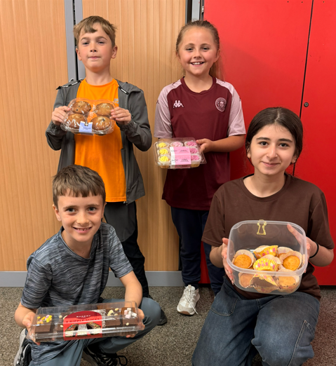
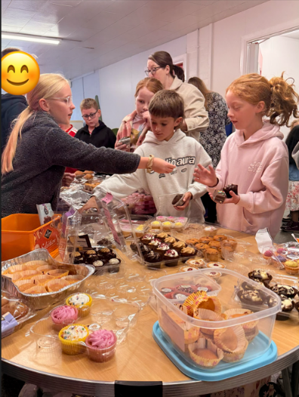



The World’s Biggest Coffee Morning

After a fabulous cake sale and coffee morning we raised £ 222.20 for Wigan & Leigh Hospice. Thank you for your support.

Wigan Athletic Visit
The children had a fabulous time learning about Achievement and the importance of having high aspirations. A valuable day's learning


Prayer for the Week
By the Ethos Team

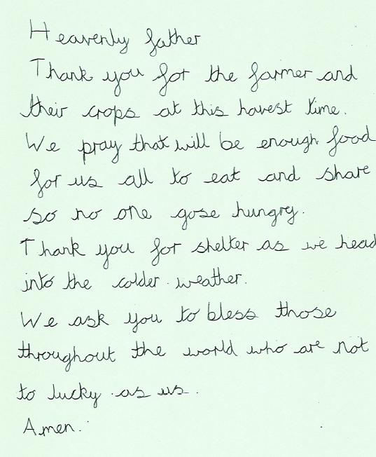

To help us maintain accurate attendance records, we kindly ask that if your child needs to attend a medical or other appointment during the school day, you provide evidence of this appointment (for example, an appointment card, screenshot of a text message, or similar confirmation).
We appreciate your support in providing this information so that we can ensure our attendance records are accurate and meet statutory requirements.
Thank you for your cooperation and support

Eco –
Jaxon , Scarlett, Ava & Theo

School Council
Noah, Honey, Harley,
Betsy, Zlata, Charlie,
Harlow, & Zachary

Ethos
Emily, Kaiden, Autumn, Haylea, Juneau, Christopher, Isla, Daniel

Librarians
Adrian, Imogen, Elsie & Sam

Head Boy & Girl
Charlotte & Luke
Meet our Club Representatives





