



“Learning and living through Jesus Christ”

Mission Statement/St Paul’s Curriculum of Grace
St Paul's C of E. School believes in the uniqueness of every child created in the image of God.
For this reason, we aim to enable each child to grow and develop in mind, body and spirit, through challenging and creative teaching within the context of healthy and meaningful relationships, set in a caring and supportive environment. All this built upon the centrality of a Christian worship and Christian values.

G od at the heart of everything we do.
R etention of Knowledge and Resilience
A spiration and Application of Knowledge and Skills
C ore Purpose – to ensure that a wide vocabulary is promoted in all subject areas.
E quality and Engagement.

St Paul’s is an inclusive school, committed to meeting the needs of all pupils with Special Educational Needs and Disabilities wherever possible. The four broad ‘areas of need’ are:
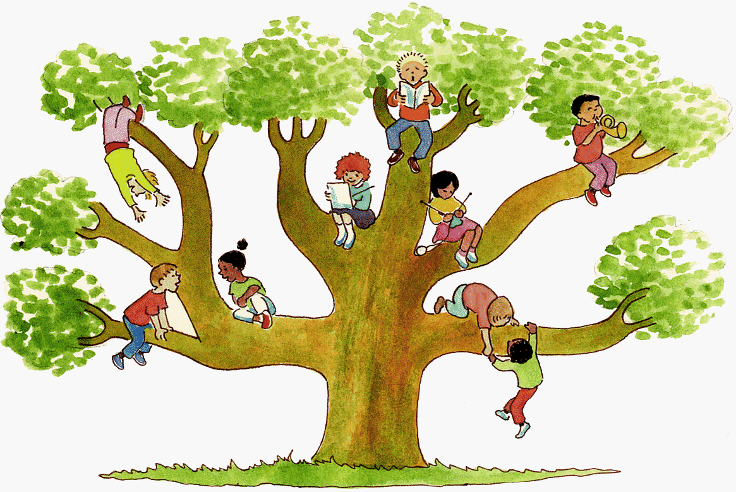
- Communication and Interaction
- Cognition and Learning
- Social, Emotional and Mental Health Difficulties
- Sensory and Physical needs

What happens if my child is identified as needing support in one or more of the areas above?
- Your child’s class teacher will discuss any concerns or observations with you.
- They will check the progress of your child regularly and identify, assess, plan and deliver any additional help your child may need in class.
- A Helping Hands Plan will be put in place to support your child. This will have individual SMART (Small, measurable, attainable, realistic, timely) targets in order to help your child’s progress. These will be updated termly and discussed with you and your child.
- If your child has not made the progress expected of them, even though the work is differentiated to meet their needs, we will contact you and may arrange a meeting with the Special Educational Needs Co-ordinator (SENDCo). This is a good opportunity to discuss what works well at both home and school and what could be done better in order to support your child as best as possible.

How will St Paul’s support my child?
- If your child is in Reception, the Early Years Team located in Wigan maybe asked to come and observe your child. They offer support and advice tailored around what your child might need at that moment in time. Throughout each term, your child’s teacher will keep them and you updated of any changes.
- Your child’s class teacher will ensure Quality First Teaching strategies are used. This is a style of teaching that focuses on high quality and inclusive teaching for every child in a classroom. The approach highlights the need for a personalised learning experience and encourages greater inclusion of pupils with SEND needs. Teachers will follow guidelines incorporated in Quality First Learning booklets. These booklets have specific targets for the children to work towards.
- If your child struggles to meet the targets in these QFT booklets, we will begin to identify any barriers to learning and suggest ways that may help your child along with you the parent.
- The school’s SENDCo, Miss Mottram will be made aware of any communication between teacher and parent and may be asked to be present during any meetings.
- The SENDCo has regular meetings with Targeted Education Support Service and the Educational Psychologist. Any advice will be discussed with the parent and support will be put in place and evaluated during the term.

- We ensure all children are fully included in all aspects of school life. At times, the curriculum may be adapted to meet the needs of children with SEND. Extra support may be put in place in class by your child’s class teacher or teaching assistant. This is dependent upon individual need but could include the use of technology (voice recorders, Ipads, computers), comments made verbally written down by a teaching assistant and so on to ensure children are achieving their full potential despite any difficulty or disability they may have.
- St Paul’s runs several interventions across the school that range from fine motor groups, gross motor groups to therapeutic Lego Clubs. It may be that your child might benefit from one of these interventions. If so, a letter will be sent home from the dedicated and trained staff member leading the group and you will be informed which group your child is in and what that group is for. If you have any questions regarding the intervention, please discuss this with your child’s class teacher or SENDCo.
- Physical Education (PE) lessons in school are planned and co-ordinated by a specialised team ‘Fit 2 Play’. Fit 2 Play will communicate with the teacher and SENDCo to deliver any further support needed for children with SEND. Lessons will be adapted to meet the needs of these children within the whole class session and reviewed regularly. A Gross Motor group is also taught by Fit 2 Play. This supports children to develop their Gross Motor skills in a smaller group extra to their usual PE lesson each week. This specialist team also work with children that have Sensory Diets recommended by the Occupational Therapist.
- If a child has any medical needs, a Health Care Plan will be put in place and distributed to staff.
- The local authority works with school to provide further support or equipment for any disadvantaged children or children that are looked after (LAC).

What specialist services are available to St Paul’s to support my child?
- The SENDCo/School/Governing Body may seek advice from health care professionals such as:
  - Wigan SEND team
  - Targeted Education Support Service (TESS)
  - Educational Psychologist (EP)
  - Occupational Therapy (OT)
  - Speech and Language Therapist (SALT)
  - Mental Health Link worker
  - Counselling service

What specialist services are available to support you as the parent?
You can refer to agencies yourself if you are concerned about your child.
- You can contact the Wigan SEND team directly on 01942 486136.
- Occupational Therapy
- Speech and Language
- Embrace offers a wide range of support and can give you contact information for many other agencies of support. They can be found at: https://www.embracewiganandleigh.org.uk
- Startwell also offer support to families. They can be found at: https://www.wigan.gov.uk/Resident/Health-Social-Care/Children-and-young-people/Childrens-Centres/Start-Well-Centres.aspx
- Children and Adolescent Mental Health Services (CAMHS)

What does it mean if my child needs Specified Individual Support?
- This type of support is available for children whose learning needs are severe, complex and lifelong. This is usually provided via an Education, Health and Care Plan (EHCP). This means your child will have been identified by professionals as needing a particularly high level of individual or small-group teaching. This type of support is available for children with specific barriers to learning that cannot be overcome through Quality First Teaching and intervention groups.
- The school will support you through this process. A number of agencies will be involved, and evidence needs to be collated over a number of terms to demonstrate that your child needs a high level of support in order to make progress.
- It is the Local Authority that makes the decision on whether an EHCP is needed for your child and funding will be allocated on an individual basis depending upon the severity of your child’s educational needs.
- There is a nominal SEND budget set aside for resources. This includes classroom equipment from sloping desks, pencil/pen grips, coloured overlays to resources used for specialist interventions such as games for the Memory intervention or bricks for the therapeutic Lego intervention.

How will school support my child with specific learning needs when starting St Paul’s or transitioning to the next stage in their education?

- Towards the end of Nursery, the Early Years team will arrange a meeting with the SENDCo and Reception teacher from St Paul’s. During this meeting, your child’s special educational needs will be discussed in detail for your child to be fully supported as they start their new setting. Any documents will be securely emailed, and funding transferred.
- As your child starts their new school, the Early Years Team will come in and observe them and offer any advice and support to the class teacher.
- If your child is in Year 6, different High Schools offer different transition programmes. The Year 6 teacher and SENDCo will liaise closely with the high schools and put any arrangements in place for children to visit their new school. If your child has specific learning needs, then extra transition visits are often offered.
- St Paul’s also have a meeting with High School staff to discuss any specific learning needs of the children in Year 6 and all relevant information is passed on to the High School.

How will St Paul’s school make adaptations to the curriculum and learning environment of children with specific learning needs?
St Pauls’s GRACE curriculum and learning environment, where appropriate, may be personalised or adapted to meet the needs of the differing learning styles of children with SEND by:
- Providing a knowledge rich curriculum responsive to the needs and interests of all children
- Bespoke provision to remove barriers to learning
- The clear expectations of ‘Quality First Teaching’ and access to high quality SEND specific booklets to support; these are monitored by the leadership team
- Differentiated resources and teaching styles
- Additional support and groupings that target specific levels of progress
- Inspiring children through exciting and challenging experiences
- Access arrangements for tests and or examinations
- Promoting perseverance, resilience, independence and an understanding of the diverse world God has created
- Setting high expectations and challenges for all children
- Equipping children with the knowledge, skills and wisdom needed for adulthood
- Raising aspirations of all pupils
- Differentiating activity, questions, resources and level of support
- Embedding the development of rich and purposeful vocabulary and language
When a child with complex SEND needs meets the criteria of disability, the school will comply with its duties under the Equality Act 2010.

How will St Paul’s enable my child with specific learning needs engage in the activities of the school together with children who do not have SEND?
At St Pauls’s School we are committed to giving all our children every opportunity to achieve their potential and develop as unique, responsible Christian citizens of the world. We have a school school approach to inclusion which supports all learning to engage in activities together. Teachers ensure that all activities are accessible for children with SEND through:
- The use of adaptations of classrooms
- The use of resources and teaching assistants
- After school and lunch clubs that are accessible to all children e.g. God Squad, Choir, Crafty Club, Eco, School Council, Ethos, Football, Netball, Dodgeball, Fun Fit Friday, Gymnastics, Wellspring.

How will St Paul’s care for my child’s emotional wellbeing (including bullying)?
- Each member of staff cares deeply about the children’s wellbeing at St Paul’s.

- There are a number of therapeutic interventions that take wellbeing into consideration for example Lego Club, Social Stories and Time to Talk. These interventions aim to support your child at recognising how to deal with different emotions and offer a calm and safe environment in order to explore their feelings. These are often small groups and led by dedicated teaching assistants.
- TLG (Transforming Lives for Good) Early Intervention programme offers weekly coaching sessions to support children with their emotional wellbeing. These sessions run for an hour a week and your child will see a trained TLG coach for a full academic year. This is a fun and creative safe space where your child will feel listened to (including any bullying concerns they may have) and encouraged, through games and activities.
- St Paul’s also buys into a counselling service. This is contacted as and when staff or parents feel this service would be of benefit to a child.
- We also have access to a Mental Health Link worker. She is available for advice and can support children on a one-to-one basis. She also gives support to parents who feel they may too need support in dealing with their child’s difficulties. The school makes a referral to this service. This service is for any child or young person within the school that may or may not have SEND. This service can also provide counselling.

Communication with parents and young people
- Your child’s teacher will use Class Dojo to communicate with you for the majority of the time. However, if a more complex matter arises, they will speak to you via phone call or invite you in for a meeting with them and when appropriate the SENDCo.
- St Paul’s has always had an open door policy and invite parents to discuss any worries or concerns they have. Termly review meetings, parents evenings and yearly reports are used to keep you up to date with your child’s progress and help you to support your child at home.
- The SENDCo liaises closely with parents on a regular basis: telephone contact, email, post, Dojo.
- Reading diaries are used for daily home school communication
- Helping hands plans are reviewed and shared with you on a termly basis
- Parent voice is important to us and we enjoy hosting regular SEND coffee mornings to meet parents. This gives parents a chance to meet other parents of children with special educational needs. Parent voice questionnaires are distributed which help identify any further support we need to put in place.
- Pupil voice questionnaires are also given out each term to a selection of children. These are so important to help us to evaluate the effectiveness of our SEND care in school directly from the children.

How will we measure your child’s progress?
- Your child’s progress will be continually monitored by his/her class teacher. His/her progress will be reviewed with the Senior Leadership Team and SENDCo every half term in reading, writing and numeracy.
- At the end of each key stage (at the end of year 2 and year 6), all children are required to be formally assessed using the Standard Assessment Tests (SATS). This is something that the government requires all schools to do, and the results are published nationally. Pupils are also formally assessed at the end of Foundation stage and Key Stage 1.
- Years 1-6 are assessed termly using NFER testing. If your child has special educational needs and is unable to access their years Nfer tests then they will be offered a test from another year. If this is still not possible, then your child will be assessed on B-Squared. This system uses small progression steps to assess your child’s progress as they develop at their own pace.
- Where necessary, children will have a Helping Hands Plan based on SMART targets or based on targets set by outside agencies specific to their needs. Targets will be set and designed to accelerate your child’s learning and close the gap. Progress against these targets will be reviewed regularly and adapted each term with your child’s input and communication with parents.
- Interventions will be monitored and adapted to suit the child’s individual needs. Children in interventions will be changed on a regular basis, however if they will still benefit from being in a group, the decision will be made by the class teacher, SENDCo, intervention leader and child for them to remain in the group. After each session, the children complete an evaluation to air their views on that week’s topic.
- The progress of children with an Educational Health Care Plan will be formally reviewed at an Annual Review with the child, their parents, professionals and school staff present/contributing to the process.
- Regular book scrutinises and lesson observations will be carried out by members of the Senior Management Team to ensure that the needs of all children are met and that the quality of teaching and learning is of a high standard.
- The SENDCo will also evaluate the effectiveness of any provision put in place by:
  - conducting spot checks on books of SEND children.
  - termly observations in class.
  - Quality First Teaching booklets are regularly reviewed, and further support offered when needed.
  - We also consider the children’s views via pupil voice questionnaires.
  - Some children require the BSQUARED assessment tool to show small steps of progress. This is tracked and reviewed termly.

Training
- The SENDCo attends regular Cluster meetings that are run by the LDST, TESS and the local authority. These provide training, important updates and any legislative changes in SEND. The SENDCo then shares this information with all staff at St Paul’s and organises the necessary training.
- Training is organised for specific subjects or specific learning needs each year. Some examples for training could be Read Write Inc courses/updates, Autism awareness, Talking Mats etc.
- Children referred to a Speech and Language Therapist will receive sessions in school. These sessions are observed by a member of staff and that programme will be followed with your child until the Therapist returns to assess them and adapt any programmes.



How is St Paul’s accessible to children with SEND?
- The front desk has a wheel-chair height section.
- There is a disabled toilet with a shower near the entrance to the school.
- The school has easy access, with double doors and ramps to access the playground.
- We ensure that wherever possible that the equipment used is accessible to all children, regardless of their needs. If a child needs specific equipment, school will provide this, for example, sloping desks, pens with grips, coloured overlays.
- After-school provision is accessible to all children; including those with SEN. Extra-curricular activities are accessible for children with SEN.
- If you require further information on arrangements for supporting children and young people with SEND who are looked after by the local authority please follow the link https://www.wigan.gov.uk/Resident/Education/Special-EducationalNeeds-and-Disability/Local-Offer/index.aspx

If you have any concerns, as a first point of call, please contact your child’s class teacher and discuss any worries you may have with them.

Who can I contact for further information, if I have further concerns or if I want to make a complaint?
Mrs Jackson – Executive Headteacher and Designated Safeguarding Officer
Mr Rigby – Acting Headteacher
Miss Fletcher – Assistant Headteacher and Deputy Safeguarding Officer
Mrs Fletcher - Assistant Headteacher
Miss Mottram - SENDCo
Mr Roberts – Chair of Governors
Mrs Faleti – SEND Governor

School telephone number – 01942 243068

The Local Offer is all the provision that is expected to be available across education, health and social care for children and young people in Wigan Borough who have SEN or are disabled, including those who do not have Education, Health and Care (EHC) plans.
- This can be found at www.wigan.gov.uk/sendlocaloffer.

The SEND Code of Practice gives guidance on the special educational needs and disability (SEND) system for children and young people aged 0 to 25, from 1 September 2014.
- This can be found at www.gov.uk/government/publications/send-code-of-practice-0-to-25

The above document has been created in accordance to the Equality Act 2010 and the Special Educational Needs and Disability Regulations 2014.

Section 6 SCOP Compliance (a)
Section 6 SCOP Compliance (b)
Section 6 SCOP Compliance (g)
Section 6 SCOP Compliance (k)
Section 6 SCOP Compliance (h)
Section 6 SCOP Compliance (6.80)
Section 6 SCOP Compliance (m)
Schedule 1 Information Report (11)
Section 6 SCOP Compliance (f)
Section 6 SCOP Compliance (l)
Section 6 SCOP Compliance (j)
Section 6 SCOP Compliance (e)
Section 6 SCOP Compliance (c and n)
Section 6 SCOP Compliance (d)
Section 6 SCOP Compliance (l)
Schedule 1 Information Report Compliance (6)
Section 6 SCOP Compliance (6.82)
Section 6 SCOP Compliance (n)
Section 6 SCOP Compliance (b)
Section 6 SCOP Compliance (6.81)

