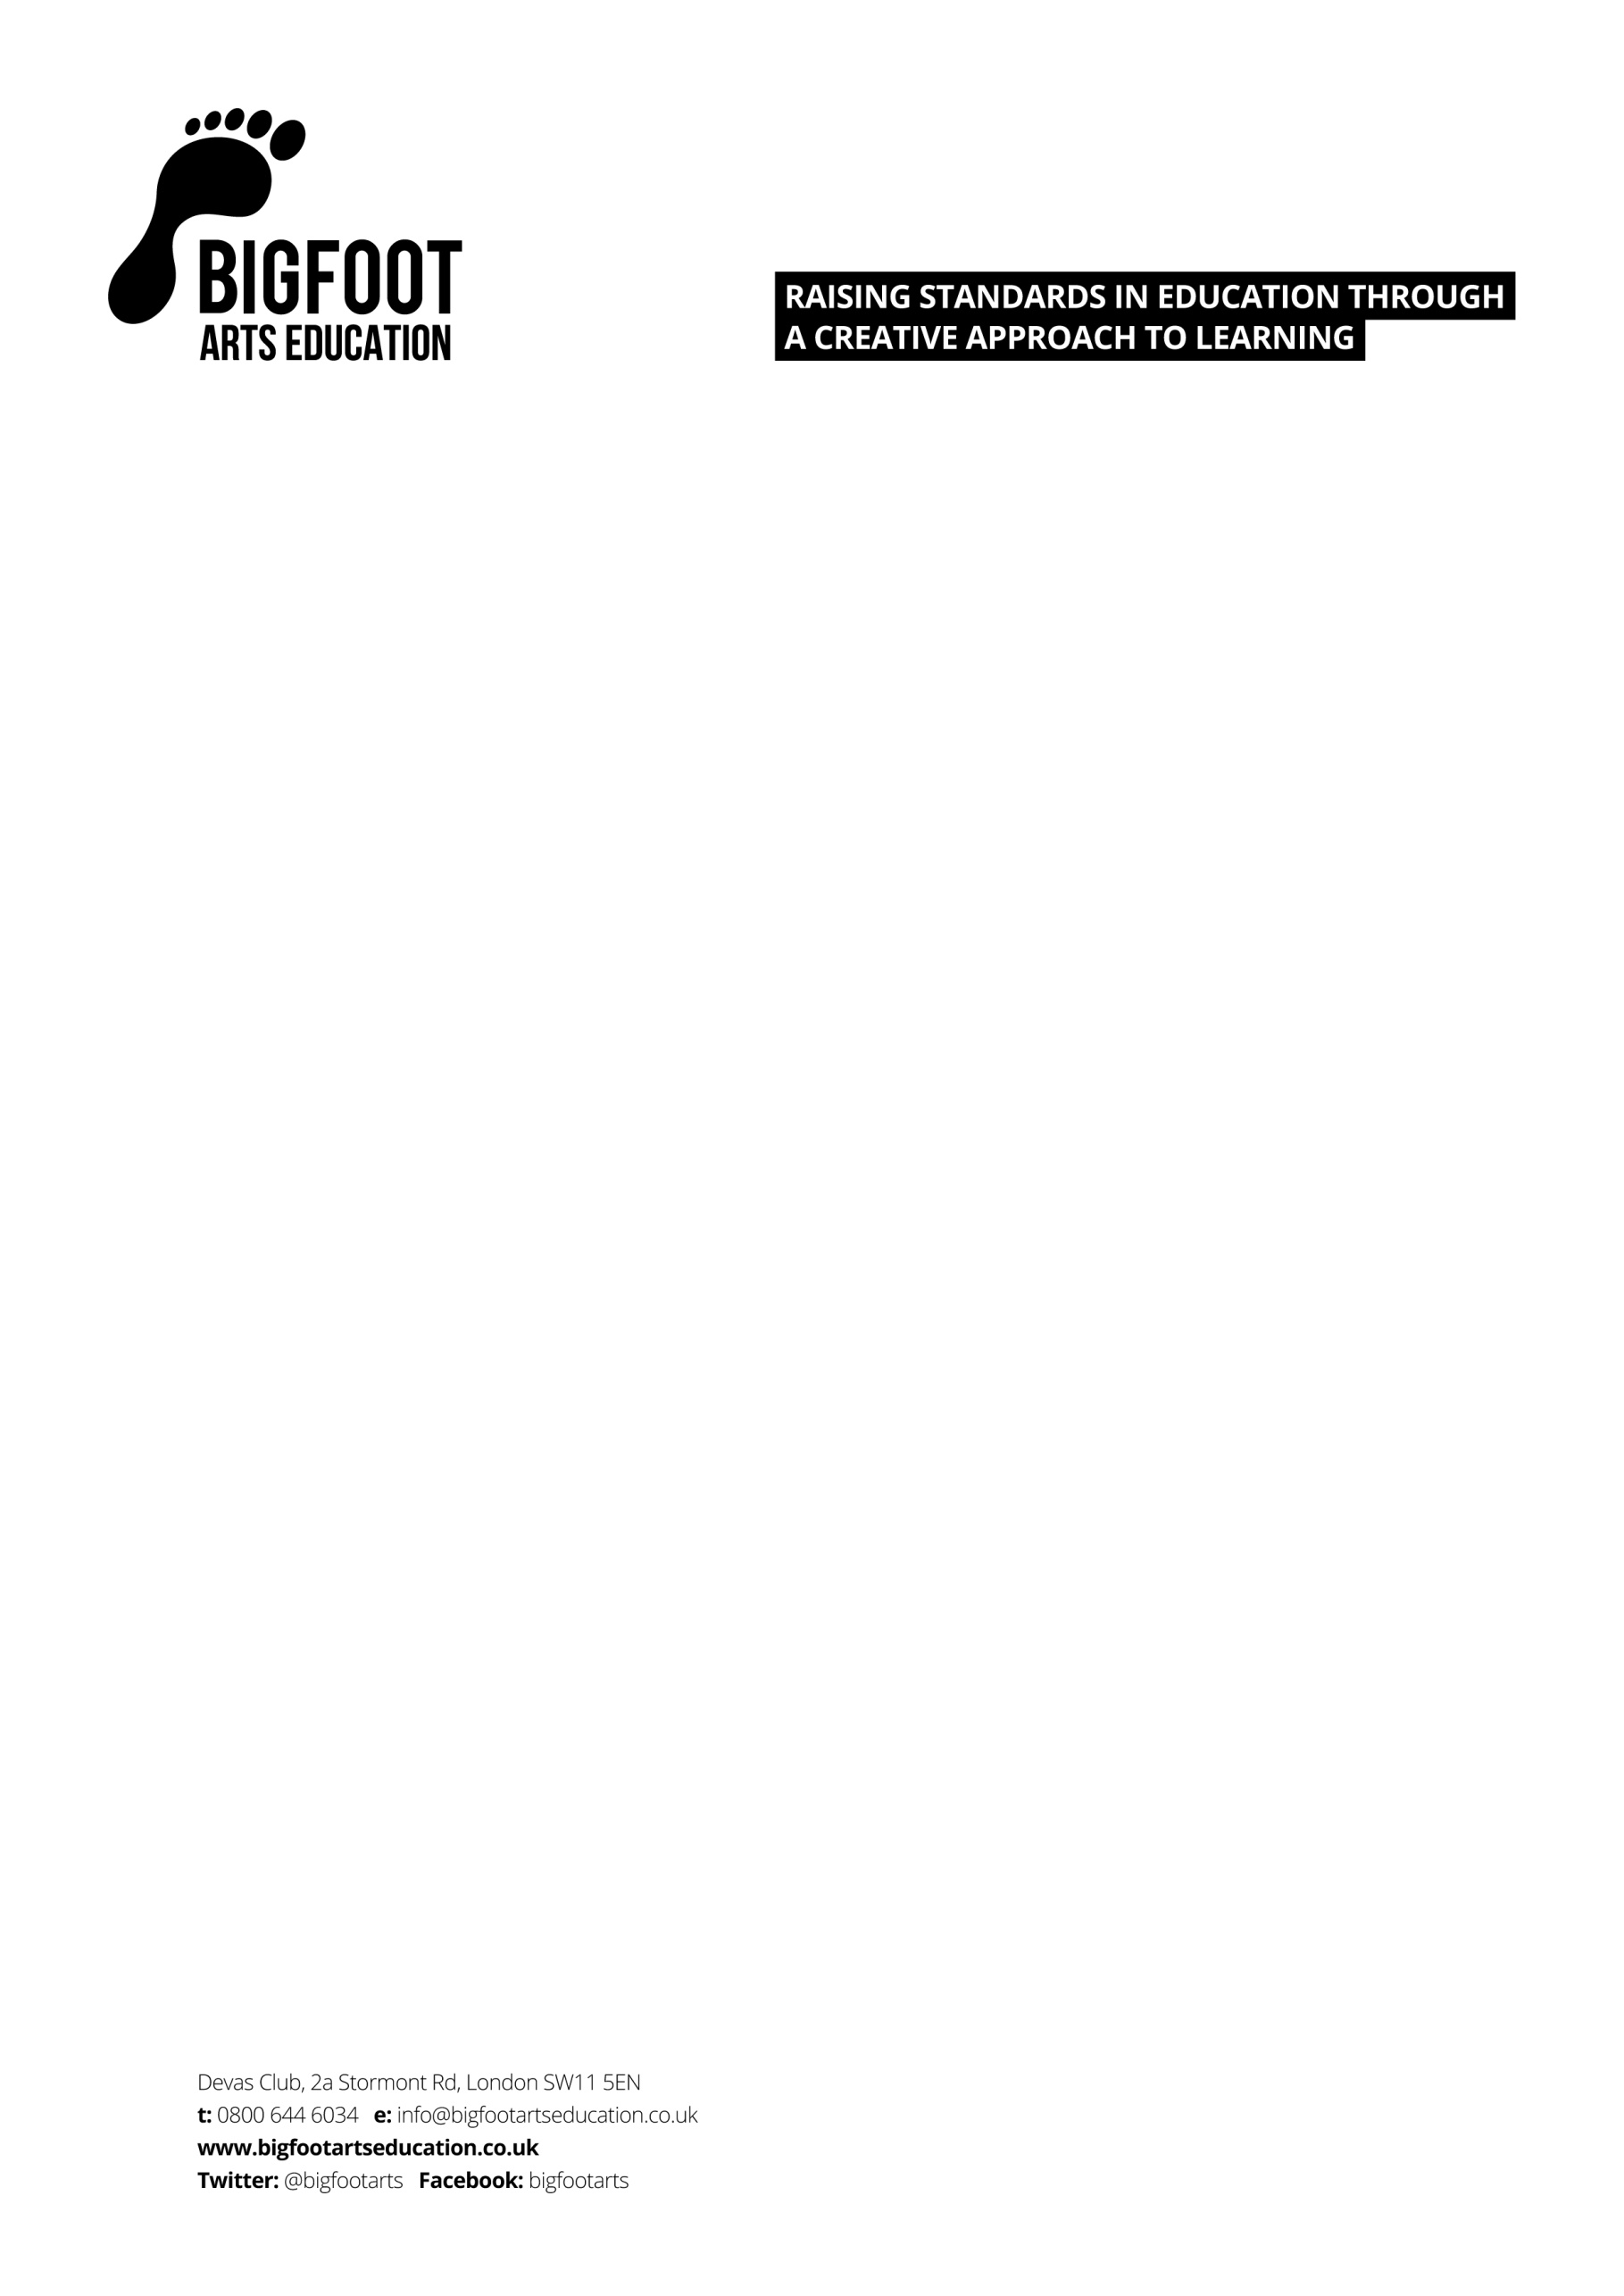

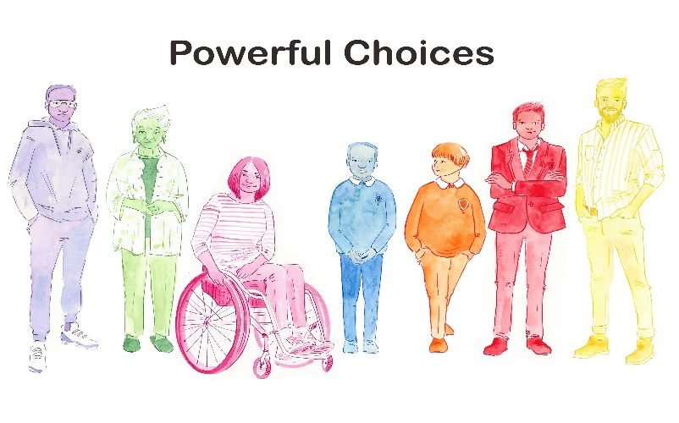
Dear Parent/guardian
We are delighted to announce that Bigfoot Arts Education will be visiting your school to deliver an educational assembly and workshop called Powerful Choices.
This programme has been designed specifically for Years 5 & 6 and is an early intervention approach to exploring with young people key messages around the topic of peer pressure, knife crime, gang violence and, ultimately, how to:
- keep themselves and others safe
- recognise and manage risk in difficult situations
- have mutually respectful relationships
- have difficult conversations with their peers and grown ups
- understand the laws around, and consequences of, carrying weapons
- access support and get help if needed.

Your child will participate in an interactive assembly with their year group, with selected classes also having a creative workshop with their class to look more intricately at how we can make informed decisions, as well as helpful conversation starters for exploring sensitive topics. This is a fantastically positive opportunity for students to work together in a safe and supportive environment in order to understand more about choices and consequences.
It is our hope that, after our visit, your children will come home and talk to you about what they have learnt. If you require any further information to help support these conversations, please utilise the wonderful parent/guardian resources that have been developed by the Ben Kinsella Trust HERE.
Best wishes,
Bigfoot Arts Education

