SEND support – Fidgets
We have been reviewing the use of fidget objects within the classroom, and also consulting with research on this topic.
Research has shown that commonly marketed fidget toys such as spinners do not consistently support attention or learning (Croley et al, 2018; Graziano et al, 2018).
Other studies also suggest that while fidget tools may provide sensory input, items like fidget spinners can actually increase distraction levels rather than improve focus (e.g., Stalvey & Brasell, 2006; Carter et al., 2017). The most effective fidget objects tend to be small, unobtrusive, and provide quiet, tactile sensory feedback. Examples include smooth stones, stress balls, or textured materials. These types of fidgets allow for self-regulation without drawing attention away from teaching and learning. Examples can be seen below. Please note, the cubes and textured balls are around the size of an ice cube and can fit discretely in a child’s hand.
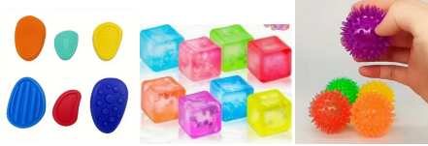

Identifying need
It may be identified by school staff that your child may need an aid to help with focus and concentration during lessons, whether that is a fidget, chewellry, wobble cushion or a chair band. If staff have concerns, they will speak to Mrs Cash, our Inclusion Manager. We will then monitor your child and agree which support would help your child the most. We will then inform you. This will then be implemented by school. Please do not send fidgets in from home; they will be provided at school.
Sometimes, these items can cause a distraction to their own learning or that of others around them. We will explain carefully to the children about how to use them appropriately to not distract anyone from learning. If the fidget or other resource is having a negative impact, we will discuss this with you.

If you have any concerns or questions, please contact your child’s class teacher or Mrs Cash.

