19th October, 2026.
Dear Parents and Carers,
Ref: Changes to Morning Drop-Off Arrangements
As part of our ongoing review of our school day, we will be making a small change to our morning drop-off procedures from Monday 2nd November, 2026
Currently, our gates open at 8:40am, with children going straight into classrooms before registration takes place at 8:50am. Whilst this arrangement has worked well for many families, a review of our school opening hours has identified that our current practice means that the school week exceeds the Department for Education's recommended minimum of 32.5 hours by approximately 50 minutes.
To ensure that we align more closely with the recommended school week whilst maintaining a smooth and welcoming start to the day, we will be introducing the following arrangement:
- School gates will continue to open at 8:40am.
- Children should be brought to their designated drop-off point on the playground.
- Parents are to supervise children at these drop-off points from 8:40am.
- At 8:50am, class teachers and support staff will collect their classes and escort them into school.
- Registration will then take place in classrooms.
This means that children will still be able to arrive from 8:40am as they do now, but the formal school day will begin at 8:50am when classes are collected and taken into school.
Benefits of this Change
In addition to ensuring that our school week remains in line with national expectations, we believe this approach offers several benefits:
- A calmer start to the day, with children joining their classes together.
- Increased opportunities for social interaction, allowing children to spend a few minutes with friends before lessons begin.
- Improved staff supervision, with all pupils gathered in designated areas before entering the building.
- A more consistent transition into learning, helping children settle and begin lessons together.
- Greater independence, as children move from drop-off points into school with their classmates.
- Reduced classroom disruption, as all children enter at the same time rather than arriving gradually over a ten-minute period.
We appreciate that any change to established routines can take time to adjust to. Staff will be available to support children during the transition and we are confident that this adjustment will help provide a positive, organised and purposeful start to each school day.

Thank you, as always, for your continued support and partnership.
Kind Regards

Mrs Karen Mowbray
Head Teacher
Reminder of drop off areas for Parents- now same as pick up areas:
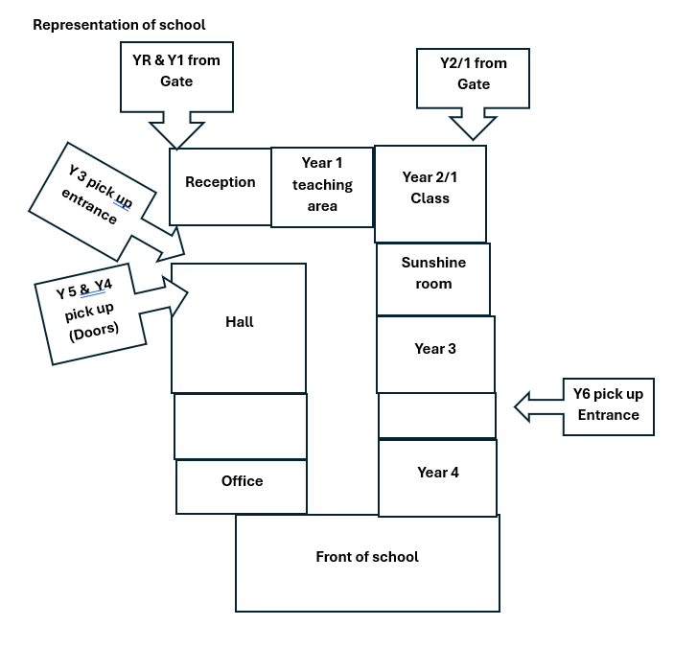
Year 2/1 may wait in the gated area outside the class in the morning only.

