English
The Man who Walked Between the Towers
Percy Jackson and the Lightning Thief
Planetarium
Robot Girl

Skills covered
Sentence level: Using different sentences types (simple, complex, compound), subordinating and co-ordinating conjunctions. relative clauses, modal verbs, adverbial phrases, fronted adverbials and expanded noun phrases. Spellings via Spelling Shed.

Maths
- Place value – understanding the value of each digit in 6-digit numbers including decimals, ordering 6-digit numbers.
- Place value – identifying and continuing number patterns.
- Place value – rounding numbers.
- Addition and Subtraction – within 1 000 000
- Multiplication and Division – multiples, factors, common factors, prime numbers, square numbers, cube numbers.
- Multiplying by 10, 100, 1000.
- Dividing by 10, 100, 1000.
- Multiplying and dividing 2, 3- and 4-digit numbers.
- Solving Word Problems.

Welcome to Year 5!
The class have settled well and are looking forward to the year ahead. Please take a look at what they will be learning this term. Homework and spellings will be given out each Friday before tests the following week.

If you have any questions, please feel free to speak to me or send a message on Class Dojo.

PSHE & SEAL

- Me and My Relationships
- Valuing Difference

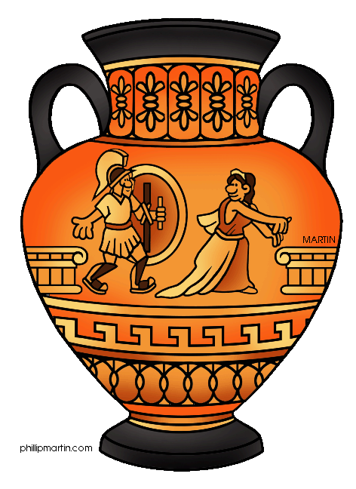
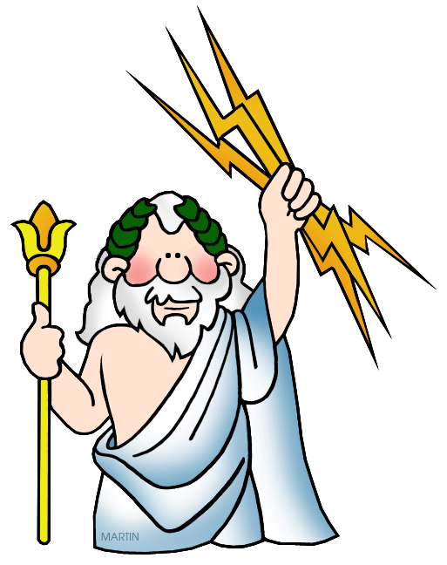
Science
- Forces and Movement.
- Earth and Space

Art/DT

- Formal elements of art and design.
- Art and design skills.
- Building bridges.
History
- Ancient Greeks
  - Use of artefacts and primary sources to examine the past.
  - Consider different types of government.
  - Investigate how other cultures worshipped.

RE
- How and Why do Christians read The Bible?
- Christmas – the gospels of Matthew and Luke.
Geography
- Human and physical Geography – Settlements – where did the Ancient Greeks settle?
  - What are the physical features of Greece?
  - How did these affect where people settled?
  - Tourism in Greece.
Computing
- Coding using Purple Mash.
- Online Safety
Music
- Compose a short song.
- The Pentatonic Scales.
- Performing extended scales.

Year 5 Curriculum Map
PE
- Invasion games.
- Performance
- Healthy Body – Healthy Mind

Autumn –
Ancient Greece

